Church Building Renovations and Repairs
May 27, 2026

After several months of work, the exterior renovations to our church and three-bay storage barn are complete. The project vastly improved the appearance of both structures.

It entailed the replacement and repair of fascias located in the front of the church and those extending along the back. Rotted wood and damaged soffits were replaced or repaired, and siding along the west side and back was either refastened or replaced.

In addition, all wood siding on the front of the three-bay storage barn was replaced with new wood because of rot and damage. The new wood and repaired siding were then finished with a fresh coat of cedar stain.

These improvements provide lasting repairs to areas that have been exposed to harsh weather over the years. They not only enhance curb appeal, but also strengthen the structural integrity and safety of both buildings, helping to ensure their long-term stability.

I am happy to report that these renovations were completed without having to conduct a special campaign appeal.

Gene Signor
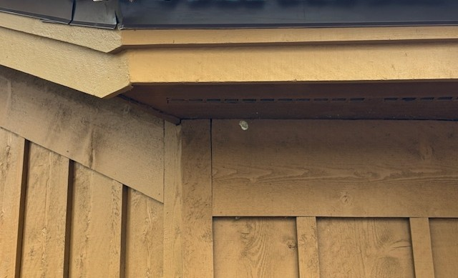
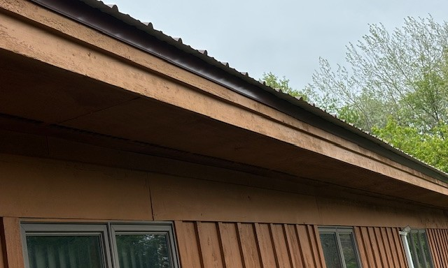
Trustees Treasurer
